Bunny Cutlery Template
Piece 1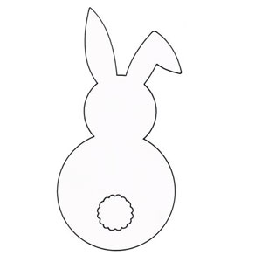

Piece 2

